Zenith Aluminum & Brass Casting Foundry
ISO9001:2000 certified
Aluminum gravity casting door grip
Casting services:
Aluminum sand casting
Aluminum gravity casting
Brass sand casting
Brass gravity casting
Aluminum prototype
Brass prototype
Sand casting mold
Gravity casting die
Permanent metal mold

Casting products:
Aluminum cast auto parts
Aluminum cast appliances
Aluminum machinery parts
Brass sand cast valves
Brass gravity cast valves
Aluminum and brass cast
Construction parts

Value added services:
Heat treatment
Electroplating
Hard anodizing
Powder coating
Painting
Electrophoresis
Impregnation
Passivation and phosphating

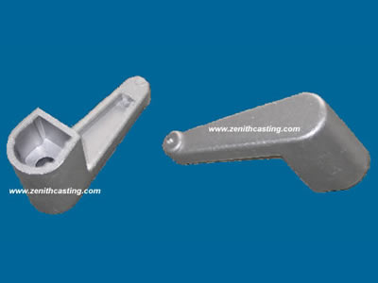

M Model series: Aluminum gravity cast door grip
Product Name: Aluminum gravity cast door grip-01
Product Origin: China
Brand Name: zenith casting
Price Terms: FOB Ningbo
Payment Terms: T/T , L/C
Supply Ability: 3,000-4,000sets/month
Tooling Lead Time: about 25 days
</l If you want to purchase or know more information about
Aluminum gravity cast door grip-01, please contact us at ease.

Welcome to Shaoxing Zenith Machinery Co.,Ltd.. Here you may find our passion for providing top quality aluminum and brass casting products and improving customers’ satisfaction. You can complete your casting design with assistance of our skilled and experienced casting engineers. Without high investment, the rapid prototype can convert your blue print into real part, and decrease development time, costly mistakes, furthermore extend product lifetime by adding necessary features and eliminating redundant features early in the design. Besides such prototype casting can also be used for low volume production.
Our own tooling workshop can make and maintain the sand casting mold and gravity casting dies. Such advantage promoted our in-house capability. Our four casting workshops can produce 100 tons of aluminum casting.
We sincerely invite you to visit our factory and establish win-win cooperation relationship.

